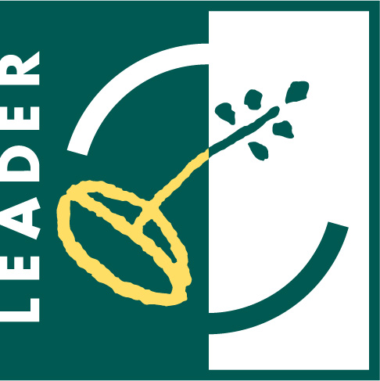 |  |   The European Agricultural  Fund for Rural Development:  Europe investing in rural areas.

Northumberland Coast and Lowlands New LEADER Approach Expression of Interest Form

For office use only:

Date received:

Project reference number:

The New LEADER Approach is a community-led way of delivering part of the Rural Development Programme for England (RDPE) across designated rural areas in the North East. Funding in LEADER areas is open to a wide range of community groups and businesses, and is worth around £1.5 million per year across the region (approximately £350k per LAG per year). In order to be considered for support, all applicants must complete an Expression of Interest Form. This will enable the Development / Funding Officer, working to the Local Action Group (LAG) for your area, to determine whether your proposal is suitable for funding. Applicants must be based in a designated LEADER area to be able to access support.

The Expression of Interest is not an application for funding, but a way of deciding whether projects should be developed further. It may be that your proposal doesn’t fit with RDPE / LEADER priorities, but could be directed to another funding stream. Your LAG Development / Funding Officer will be able to help you with this. To be able to proceed to full application, your project must deliver against one or more of the following RDPE / LEADER priority themes:
- Micro Enterprise Development
- Bioenergy
- Sustainable Farming and Forestry
- Sustainable Communities
- Tourism and Recreation
- Natural and Cultural Assets (N.B. this theme is being delivered primarily through the Environmental schemes operated by Natural England and the Forestry Commission).

For further information about these priorities, and the activities that may be eligible for assistance, please visit: www.rdpenortheast.co.uk. Or speak to your LAG Development Officer.

Each LEADER area has prepared a Local Development Strategy (LDS) that sets out how the LAGs wish to deliver RDPE objectives in their area. The strategies are also available in electronic format on the RDPE website.

Name of project:

CONTACT DETAILS

Name of your organisation/group/business:

Main contact:

Position held:

Contact address:

Postcode:

Telephone number:
E-Mail address:
Alternative contact details:
How would you describe your organisation? (please tick)
Registered charity |  | Registration no:
Company limited by guarantee |  | Registration no:
Company limited by shares |  | Registration no:
Community interest company |  | Registration no:
Unincorporated club or association

Public sector

Other (please specify)

PROJECT DETAILS

Please state which of the RDPE LEADER priority themes your project fits and provide a brief explanation. (Projects may address more than one theme).
Micro-Enterprise Development:

Sustainable Farming and Forestry:

Tourism and Recreation:

Sustainable Communities:

Bioenergy:

Natural and Cultural Assets:

Please provide a summary of your project, in no more than 500 words. You should include in this:
- A brief description of your project idea;
- Why the project is needed;
- Where the project will be based, and who will benefit (these should be people in rural communities);
- Expected start and finish date (please note that work cannot begin until funding is agreed);
- What the benefits will be (the difference or impact the project will have, for example, jobs created, organisations supported, training given).

PROJECT COSTS

How much RDPE LEADER funding are you applying for? Please note that LEADER funds are limited; if your project is seeking over £50k in RDPE LEADER funds you may need to look for alternative support.
RDPE LEADER funding sought: | £
Please provide, if possible, any potential or confirmed sources of match funding:
Private funds (e.g. savings, bank loan) | £
Other public funds (e.g. Local Authority grant, Lottery) | £
Charitable / Voluntary Sector (e.g. Northern Rock Foundation) | £
Other (please state) | £
Overall cost of your project: | £
If possible, please provide some detail about the costs associated with your project (e.g. capital and revenue costs). | Item | Cost

AUTHORISED SIGNATORY

This section must be signed by someone with the required authority (e.g. Chairperson). An electronic signature is acceptable.
I confirm that, to the best of my knowledge and belief, all the information in this Expression of Interest is true and correct. I understand that, should this proposal be further developed, you may ask for additional information at any stage of the application process. In the event that the proposal is unsuitable for RDPE LEADER funding, I agree to these details being passed to an appropriate body for further assistance.
Signed |  | Print name
Position |  | Date

PLEASE EMAIL (if possible) A COPY OF THE COMPLETED EXPRESSION OF INTEREST TO ivan@leadercoastandlowlands.org.uk

AND RETURN A SIGNED HARD COPY OF THIS FORM TO:

IVAN HEWITT

LEADER Coordinator (Coast and Lowlands)
Trust in the North
Lynemouth Resource Centre
Bridge Road
Lynemouth
Northumberland
NE61 5YJ

Tel: 01670 863007
Mob: 07766694520
Email: ivan@leadercoastandlowlands.org.uk

